**LTWC CSG**

**Issue:** Aged disconnect cannot be completed – Error “O3C36E – Cannot Close, Pending PRVSN”

Attempts to complete a pending disconnect order results in the error “O3C36E – Cannot Close, Pending PRVSN”

* 1. These are caused by open SODI or NG tasks on this order, “ghost prov” or potentially a previous “completed” order that still has an open SODI or NG task.

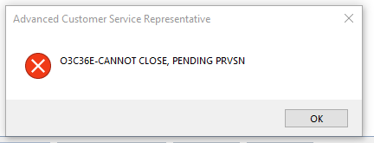

**Check for Assigned SODI Tasks**

Go to the “provisioning details” tab within the order, and click “tasks” to see if there’s any pending provisioning orders. If a SODI task is “assigned”, check for an open job

1. In this example, there’s an open SODI task

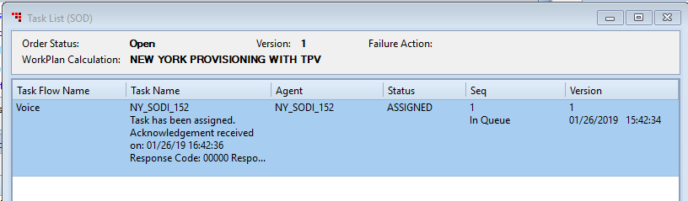

* + - Job exists:
      * If there’s an open job, make sure the order can be completed (not future billed, has the right equipment, techs have gone out…etc), then complete the job
      * This will allow the SODI task to complete anywhere from a few minutes to overnight
    - Job doesn’t exist:
      * Add a new disconnect job, assign the items to it and add notes. Schedule the job for todays date (or as soon as you can) and finish the order
      * Re-open the order, select “comp as ordered” for the job, use completion code “CP0” and finish the order
      * This will allow the SODI task to complete anywhere from a few minutes to overnight

**SODI Show’s Complete (GHOST PROV)**

If SODI shows Complete, but the error “O3C36E – Cannot Close, Pending PRVSN” still prompts, then there may be a “Ghost Prov” issue.

* Example of completed SODI task

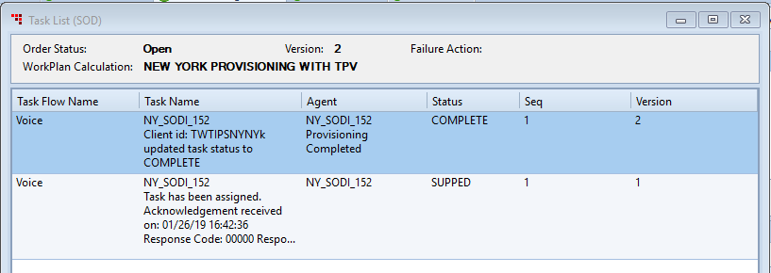

1. Check OSM
   1. Some agents within the department have access to OSM and can check to see if there’s any open items that needs to be completed. Asking in the general floor chat for someone with access to check can be helpful.
2. Check AgentOS
   1. Make sure the services show active under the equipment listed in the “Device Management” tab

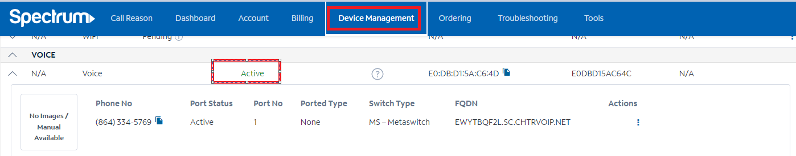

* 1. If the device status does not show “Active”, select the action button and look for an “Activate” option. If available, attempt to activate the equipment.
     1. This will require the MAC address of their equipment. Obtain this from CSG and attempt activation

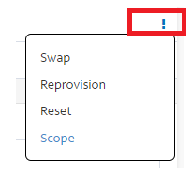

1. If there are no items that need completed in OSM and their service is activated to their equipment, then a JIRA ticket for a “Ghost Prov” will need submitted to resolve the issue
2. Access JIRA and create a ticket to Billing Configuration Advanced Support (BCAS).
3. Select “Create an issue”



1. Select the following options, then click “Next”
   * Project = Billing Configuration Advanced Support (BCAS)
     + The “Project” box is also searchable. Typing “BCAS” will locate the correct group
   * Issue Type = External Request

1. Fill out the following information (if the option is not mentioned below, it can be left with its default selection/info)

(Full Size Ticket Sample on page 3)

* **Team Impacted** = Collections Support
* **Priority** = P2 Major/Medium
* **Category** = CSG
* **Type of Work** = Option closest to issue
* Misc. Collections Request if none match
* **Quantity** = 1
* Possible testing for multi-account issues in the future
* **Account #**
* **Customer Type** = RES
* **Legacy Company** = TWC/ CHTR / BOTH
* **Description** = Detailed description of Ghost prov issue (SODI shows complete, still getting pending prov)
* **Target Completion Date** = Today’s Date + 2 biz days

*TMS ID, BDS #, BRF and attachments can be entered into their respective fields if available*

1. Select “Create”
   * If a required field is forgotten, JIRA will prompt to have that field filled out
2. Ticket is created, and the ticket number is located at the top of the request, in this sample, the ticket number is “BCAS-152”. The URL also shows the ticket number.

* The URL can be copied and does link directly to the ticket

